From:

Bullies Don’t Win at Diplomacy

President Donald Trump is learning that, just because the United States is powerful, that doesn’t mean it can push other countries around

Foreign PolicyFollow
Jun 7, 2018
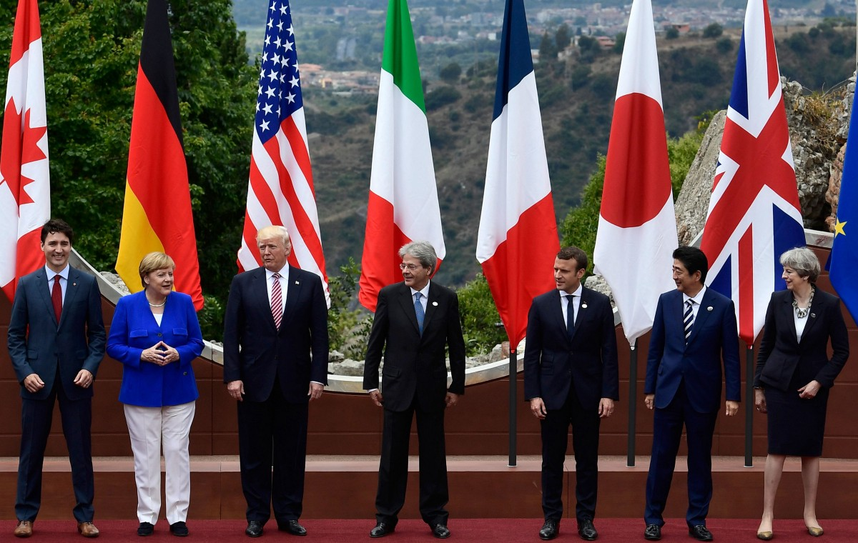
Canadian Prime Minister Justin Trudeau, German Chancellor Angela Merkel, U.S. President Donald Trump, then-Italian Prime Minister Paolo Gentiloni, French President Emmanuel Macron, Japanese Prime Minister Shinzo Abe, and U.K. Prime Minister Theresa May pose for a photo at the G-7 summit in Sicily on May 26, 2017. Photo: Miguel Medina/AFP/Getty Images
By Stephen M. Walt
Successful foreign policy requires combining the various instruments of national power to produce a desired positive outcome. Because each state coexists with many others, in practice this means using those instruments to persuade both allies and adversaries to act in ways that will further the state’s own interests. Thus, an effective foreign policy depends on an accurate understanding of other states’ preferences and how they are likely to respond to one’s own initiatives.
U.S. diplomat George Kennan’s vision of containment is an apt example. Containment correctly identified the critical objective — keeping the industrial power of Western Europe and Japan out of Soviet hands — and Kennan understood that nationalism was a more powerful force than Marxism and that the states that were threatened by Soviet power would be powerfully inclined to balance with the United States. Kennan also foresaw — again, correctly — that the Soviet Union would eventually “mellow” if it were denied meaningful opportunities to expand. And that is pretty much what happened.
By contrast, the George W. Bush administration’s ill-fated decision to invade Iraq in 2003 was based on a complete misreading of the situation it faced and the likely response of other key actors. Not only did the administration overstate the U.S. ability to re-engineer a foreign society, it failed to recognize that other states (and nonstate actors) would join soon forces to oppose the U.S. effort. Instead of sparking a democratic transformation of the Arab and Islamic world — as its architects naively foresaw — the occupation became a costly quagmire and made the terrorism problem worse.
The point is that success or failure in foreign policy depends in good part on whether one’s strategic choices are based on an accurate view of the world and the key forces at play within it. If government officials misread others’ preferences, or simply don’t understand the forces that will determine how other states will respond to whatever actions they take, their policies are likely to fail.
Which brings me — naturally — to the Trump administration.
Although it is tempting to interpret President Donald Trump’s erratic, impulsive, and self-absorbed approach to U.S. foreign policy as essentially a not-very-entertaining form of reality TV — that is, as a deliberate series of casting changes and cliffhangers intended to hold attention and keep viewers tuning in — there are two consistent themes to his approach to the rest of the world.
The first theme is a tendency to view relations with other countries on a purely bilateral and transactional basis, and to judge success or failure solely by whether the United States is getting the better end of the deal in each case. In Trump’s mind, you’re either the con man or you’re the mark, and a successful foreign policy is one where every bilateral relationship works out better for the United States than it does for the other side. If both sides gain equally, or if both sides gain a lot but the other side gets a bit more than the United States does, then it is by definition a bad deal, even if it America better off in absolute terms. Like any good huckster, Trump always wants to get something for nothing, and to be able to tell the American people that he’s somehow persuaded foreigners to make tons of concessions without giving them anything in return. You know: like promising that Mexico will somehow pay for a wall that it doesn’t even want.
The second and closely related theme is a propensity for bullying. Whether he is threatening to tear up existing deals, rain “fire and fury” down on an enemy, or impose tariffs on friend and foe alike, Trump’s diplomatic modus operandi rests on the belief that the United States has a nearly infinite capacity to impose its will on other states by issuing threats.
If Trump refuses to reaffirm Article 5 of the North Atlantic Treaty, other states will pay the United States to defend them.
- If he denounces NAFTA and threatens to leave it, Canada and Mexico will quickly give in to whatever U.S. negotiators demand.
- If he threatens China with a trade war, President Xi Jinping will leap to do whatever it takes to make Trump happy. And
- if he tears up the Iran nuclear deal, the ayatollahs won’t dare to resume enrichment and move closer to Russia and China.
- If he treats longstanding U.S. allies with contempt, ignores their earnest pleas on the Iran deal, and then slaps tariffs on them too, they’ll just meekly accept the humiliation and quietly back down.
To be fair, one can see why someone like Trump might think this way. After all, the United States is still very powerful, and it still has the world’s largest and most important economy. The dollar is still the world’s reserve currency, which gives Washington unusual leverage on global financial dealings. No major power wants to be cut off from the U.S. economy — even a little — and no corporations or foreign banks want to be denied access to the U.S. financial system. The United States is also in an extremely favorable and secure geographic position, with no serious enemies nearby, which means that most of its allies need it more than it needs them.
Add to these advantages the fact that many states are accustomed to depending on Uncle Sam for their security and are fearful that U.S. protection might be removed. America’s European allies worry about having to defend themselves without a lot of U.S. help, and they worry even more about the possibility that inter-European rivalries would intensify if the “American pacifier” were gone.
The bottom line, therefore, is that few, if any, states are eager to invite the ire of the United States, or even to get into a long, bitter, and protracted arm-wrestling match with it. Like the majority of Americans, current U.S. partners are mostly hoping that Trump will prove to be an unhappy but short-lived moment in U.S. history, rather than a fundamental historical turning point. This would seem to lend credence to Trump’s foreign-policy-by-browbeating approach.
But there are two obvious reasons why this view of the world is mistaken.
First, a purely transactional and essentially bilateral approach to foreign policy makes it much harder to forge larger coalitions in the service of shared objectives. If success is defined as striking bilateral deals that are always better for the United States than for any of its partners, the result is to treat potential allies as if they were adversaries and thus to lose the hope of enlisting the former against the latter. Case in point: Trump’s foolish decision to abandon the Trans-Pacific Partnership undercut U.S. relations in Asia and reduced its ability to pressure China, thereby undermining Trump’s own stated objectives. Trump repeated this blunder last month when he imposed tariffs not just on China but also on many other U.S. trading partners. It is hard to exaggerate how stupid this was: Not only will it hurt the U.S. economy by making imported steel more expensive (and there are far more jobs in steel-consuming industries than in steel production), but it also isolated the United States within the G-7 and pushed China and Europe closer together.
As former Treasury Secretary Larry Summers wrote in the Financial Times this week, “A second rule of strategy is to unite your friends and divide your potential adversaries. The US seems to be doing the opposite. … the result [of U.S. policy] has been to cause most of the rest of the world to take China’s side against the US.”
The second problem is that Trump & Co. have overstated the amount of leverage at their disposal and failed to appreciate the different strategies that friends and foes can adopt to tame American power. The United States does enjoy many advantages, but other states do not simply have to bow to its whims and dictates. Even at the height the so-called unipolar moment, when American power was at its peak, vastly weaker states still found ways to deflect, stifle, distract, bind, bog down, exploit, or resist U.S. pressure. States can balance U.S. power by coordinating their positions with others, or creating alternative institutions that bypass Washington as the remaining members of the TPP are doing. Or they can simply balk at whatever the U.S. proposes, dragging things out interminably. Other states and some nonstate actors can defy the United States not by trying to confront it directly but by some sort of asymmetrical response, such as acquiring weapons of mass destruction or employing terrorism. And really clever states can try to exploit U.S. power for their own ends, as Israel, Saudi Arabia, and some others have done.
The more the United States tries to throw its weight around, and the less respect it shows for the “decent opinion of mankind,” the more incentive others have to resist and the more effective all of these tactics become. The more fights Trump picks, the more leaders he insults, the more erratic his behavior becomes, and the more embarrassing his personal conduct, the more that other countries will simply start to ignore the United States or offer no more than polite, mostly insincere, support. Even world leaders who might be inclined to support him will have to think twice about doing so if their publics increasingly regard the United States in negative terms. We see this trend already in the declining number of people around the world who express confidence in U.S. leadership, the greater respect that global publics give to leaders like Xi Jinping (or even Russian President Vladimir Putin) compared to Trump, and the growing number of formerly pro-U.S. leaders who speak openly of taking their fate into their own hands and ignoring the unguided missile who now inhabits the Oval Office.
In the short term, the results of Trump’s twin errors may not be all that momentous. As long as he doesn’t do anything really dumb — like starting a war with Iran — and assuming his bluster doesn’t provoke a real trade war (as opposed to the modest skirmishing currently underway), the United States will probably muddle along reasonably well. Trump will have done nothing to “Make America Great Again,” but did any serious person really think he would?
In the meantime, U.S. rivals will continue to secure incremental advantages, America’s voice won’t be heeded as often, and Americans will live less well than they could have. But if the decline is modest and the steady erosion of the U.S. constitutional order is sufficiently gradual, many people may not even notice — which is no doubt what Trump and the Republican Party are counting on.

Stephen M. Walt is the Robert and Renée Belfer professor of international relations at Harvard University.

